ASK Modulation and Demodulation

Institute Of Engineering And Technology

Subject: Analog And Digital Communication

Instructor: Mentor:

Mr. Ashok Ranade Mr. Smith Tripathi

Group Members:

Ashutosh kakadiya 1401075

Deep Talati 1401085

Harsh Mehta 1401086

Kishan Raval 1401117

Amplitude Shift Keying

Amplitude-shift keying is a form of amplitude modulation that represents digital data as variations in the amplitude of a carrier wave. In an ASK system, the binary symbol 1 is represented by transmitting a fixed-amplitude carrier wave and fixed frequency for a bit duration of T seconds.

Amplitude shift keying is a type of modulation where the amplitude of the modulated signal is proportional to the modulating signal. The spectrum of the ASK modulated signal is centered on the carrier frequency.

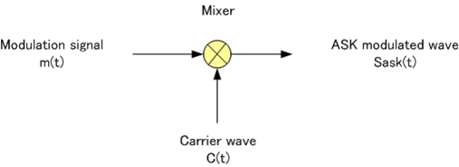

Modulation

Binary Modulation

* In binary modulation, the message sequence has two levels, 0 and 1. Thus the modulated waveform consists of bursts of a sinusoid.

M-ary Modulation

* In M-ary modulation, the message sequence has M levels. For every level there is different amplitude of sinusoid.

Application

* ASK is used to transmit digital data over optical fiber.

Advantages

* ASK modulation and demodulation processes are relatively inexpensive.
* One important advantage of ASK is, it need less bandwidth than FSK.

Disadvantages

* ASKisverysusceptible to noise interference. Noise usually affects the amplitude therefore ASK is the modulation technique most affected by the noise.

Demodulation

Types of demodulation:

* Coherent
* Non-Coherent